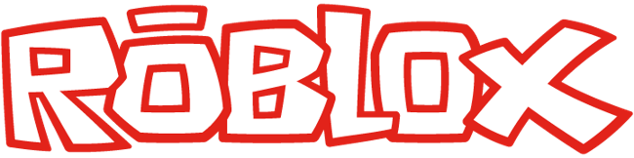

Quarterly Check In

Rick
1Q16

DISCUSSION
How did you do last quarter?
Rick Response:

Q1 ACTUAL:
- 31 Offers
- 17 Hires Q1
- 2 Offers Outstanding
- 8 Confirmed April Starts
- 58% Offer Conversion Rate
- 62.33 Day’s Time to Hire Avg.
- Pipeline
- 5,500 Applied
- 525 Assessed
- 147 Face to Face
- .026% Applied to Live

Evaluation:
Very strong effort, hard work and consistency resulted in a strong close to the quarter making up for a slow start. Brute force effort.

Ratio of Technical phone screens converting to live interviews and Offers to hires will be the main focus of improvement for Q2.

Andy Response:

What are you goals this quarter?
Rick Response:

- Q1 Strong emphasis on “numbers”
- Q2 Quality of candidate, working smarter, being more confident in ability to recruit and less “needy” with offers.

Q2 Goal VS Q1 Actual-Metrics:
___________________________________________________________________________________________________________________
Interviews:

Engineering:
- 10-20 Phone Screens Max Weekly
- 5-10 Lives Max Weekly
- 2-3 Hires a month
Web:
- 10 phone interviews
- 5 Lives Max a week
- 2-3 Hires a month
Other:
- 10-20 Phone interviews
- 10 Lives
- 2-3 hires a month
___________________________________________________________________________________________________________________
Hires
- 27 Q2
- 9 a month
Pipeline
- 5% Applied to Live Ratio

Time to Hire
- 42 Day’s avg.
Conversion Rate
- 90% Conversion Rate
Individual:
- Manage team to quarterly metrics, achieve team quarterly goals
- Grow confidence, skill set of team to better manage and control candidates through process and offer
- Lead by example of working smart and upholding Roblox core values
- Establish and Document Comp., Hiring, Internal Referral Process
- Implement Hiring manager and team interview training quarterly brown bag
- Customize Greenhouse with Recruiters and Hiring Managers to focus interview objective
- Close quarter with a clearly defined interview process and methodology per department
- Establish strong Internal Referral foundation
Andy Response:

What are your longer term goals?
Rick Response:
- Drive best in class recruiting organization at Roblox
- Establish recruiting as key player in Roblox growth-success with high functioning, ever evolving, effective recruiting organization
- Learn, grow and evolve to become Roblox VP, Talent Acquisition-Programs through effective action and results
- Consistently establish recruiting team as top performers
- Consistently establish myself as company’s top performer by way of the team’s success
Andy Response:

VALUES Rank (5 best, 1 worst)
Rick Andy
Self Organize 4
Get Stuff Done 4
Inspire Others 4
Work Hard 5
Respect the Community 5

